6. Describe how you would test an airplane or bicycle by test levels.

First of all we need to define acceptance criteria. For example:

Our team has to create a bike with 2 wheels, bike frame, handlebar, chain, one speed, 2 pedals, brakes and lights.

Color - red;

Weight - 10 kg.

Suppose that bike consists of these units:

1. wheels
2. bike frame
3. handlebar
4. chain
5. pedals
6. brakes
7. lights

The first level of testing is Unit testing. At this level, we test individual Units. For example:

1. The tester is checking wheels. That they are round, spinning, etc.
2. Testing bike frame. It has the correct size and characteristics.
3. Testing handlebar. We check that the handlebar corresponds to the specification.
4. Testing chain.
5. Testing pedals
6. Testing brake
7. Testing lights

Next level is Integration testing. We combined units and tested as a group.

1. Connect the wheels, bike frame and brakes and test that this construction works.
2. Combine the handlebar and lights and check construction.
3. Connect the chain, pedals and brake.

Next level System testing. We combine the system (bike) and evaluate how the various components interact together.

At this level, we can do various tests:

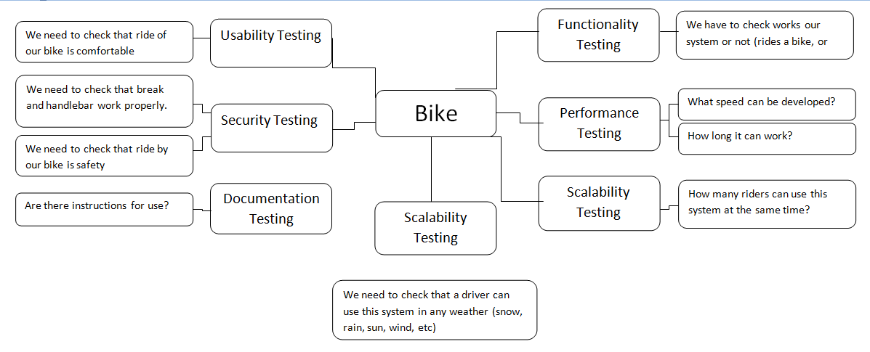

Acceptance testing. We check that our product (bike) meets acceptance criteria.

Alpha-testing - employees ride our bike in turn))

Beta-testing - friends of the employees ride our bike in turn and leave their feedback.